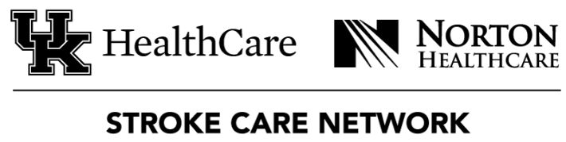
2022 SCN Summit Evaluation
October 13 & 14, 2022

- Have you previously attended a SCN Summit? YES NO

- What was your favorite part of the SCN Summit this year?
____________________________________________________________________________________________________________________________________________________________________________________________________________________________________________________________________________________________________________

- What could we improve for next year?
____________________________________________________________________________________________________________________________________________________________________________________________________________________________________________________________________________________________________________

- What suggestions do you have for the content of next year’s event?
____________________________________________________________________________________________________________________________________________________________________________________________________________________________________________________________________________________________________________

Thank you for attending the 2022 Stroke Care Network Summit!
Please return this form to SCN_Education@uky.edu

